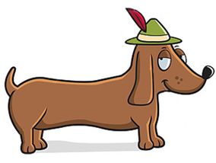
Running of the Weenies
Downtown Florence, SC | October 8, 2022
Entry Form-$5.00 Entry Fee
Please fill out the information below.

_______ “Running of the Weenies” Race ________ “Almost a Weenie” Race

Dog’s Name:_______________________________________

Age:__________ Weight:________________ Color: ________________________________

Coat: ______________________________________ M:________ F:________ N:_________

Immunization Date: _________ Rabies #______ Vet: __________________________________________

Owner Name:___________________________________________________________________

Owner Address:________________________________________________________________________

City:___________________________________________ State: ______________ Zip: _______________

Email: ______________________________________ Phone: ___________________________________

Assistant Name: _______________________________________________________________________

Official Participation Rules
Please initial next to each rule and provide your signature at the bottom.

___Owners and assistants must sign the rules page and waiver in order to participate.

___ All dogs must have proof of current rabies vaccination either via tag or veterinary certification.

___ All racing dogs must be accompanied by two handlers including one owner and a helper to assist dog at the starting line and finish line. Owners may coax racing dogs with toys, chews, or verbal cues. Dog whistles, balloons, breakable items, and electric collars will not be allowed.

___All owners must sign a media release and consent waiver releasing all organizing parties and others from all liabilities associated with canines interacting with other canines and people of all ages. The City of Florence, Florence Area Humane Society, Florence Downtown Development Corporation, and race organizers are not responsible for any injuries, human or canine, emotional or physical. Please consider the demeanor and socialization of your dog before deciding to participate in the race. If your dog is not friendly to people or canines, please do not participate in this event. Dogs with aggressive behavior will be removed from the competition. We want happy hounds and humans!

Running of the Weenies
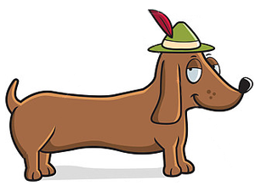
Downtown Florence | October 8, 2022
Rules, Continued.

___All participating racing dachshunds must be registered and/or checked in before 5:45 p.m. on race day. All racers must be dachshunds as determined by the race official on site. If your dog is a dachshund mix, you may enter and race in the “Almost a Weenie” race.

___All dogs must remain on a leash until the participating dog’s racing time and must be leashed immediately following the participating dog’s racing time.

I have read and understand the above mentioned rules for participating in the “Running of the Weenies” and “Almost a Weenie” dog races.

Owner signature: ___________________________________________________ Date:_________________

Assistant Signature: _________________________________________________Date:_________________

Waiver and Release of Liability

In consideration of being permitted to participate in the 2022 “Running of the Weenies” and “Almost a Weenie”, I do hereby agree to its rules and regulations and hereby for myself, my heirs, executors, administrators, and assigns do hereby waive, release, and discharge the City of Florence, Florence Area Humane Society, and Florence Downtown Development Corporation, its officers, directors, employees, agents, volunteers, or any other party from any and all damages, death, personal injury, or property damage which I may have or which may subsequently occur to me or my canine as a result of my participation in this event.

This release is intended to discharge the above mentioned parties from and against any and all liability arising out of negligence or carelessness on the part of the released parties or entities mentioned above.

I certify that my dog is properly vaccinated and will provide proof of current rabies vaccination either by tag or veterinary certification. I agree to keep my dog on leash at all times, with the exception of specific racing times. I will permit free use of photographs of me or my dog in all types of media coverage and promotion for this event or events in the future.

I, the undersigned, verify that I have read and will abide by all rules and regulations pertinent to this event, waiver, and release of liability. I further verify that I am at least 18 years of age.
I have read this release and fully understand it, and I voluntarily accept it. I understand that this release states the entire agreement with the released parties or entities mentioned above.

Signature (Owner): ____________________________________________ Date: _____________

Signature (Assistant):____________________________________________ Date: ____________

